## Configuring SharePoint Server 2010

**Lab Time**: 45 minutes

**Lab Folder**: C:\Student\Labs\03.Configuring

**Lab Overview**: In the following lab, you are going to get experience moving around within the SharePoint 2010 Central Administration application.

Lab Setup Requirements

* Before you begin this lab, you must complete the previous labs successfully.

### Exercise 1: Getting Around in Central Administration

In this exercise you will be accustomed with SharePoint 2010 Central Administration.

1. In the previous lab you ran the **SharePoint 2010 Configuration Wizard**. When the wizard completed, you were then redirected to **SharePoint 2010 Central Administration**. If you are not already at **SharePoint 2010 Central Administration** then navigate there using the shortcut in the Windows Start menu of **Start » All Programs » Microsoft SharePoint 2010 Products » SharePoint 2010 Central Administration**.

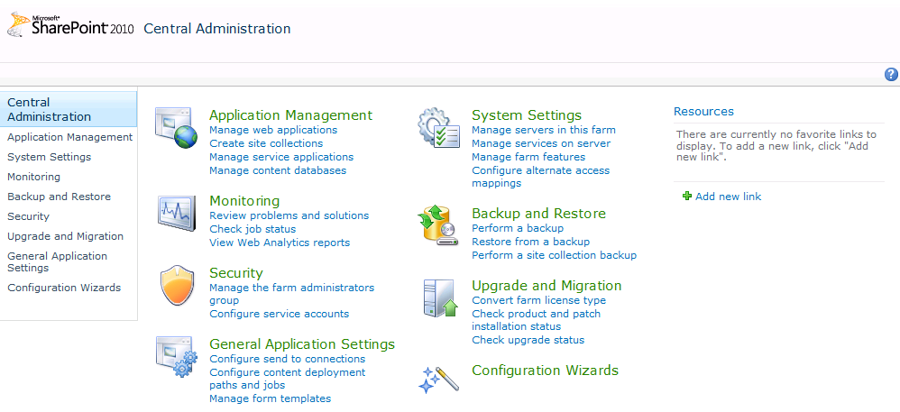

1. Look through the links on the home page of **SharePoint 2010 Central Administration** and locate each these sections:

Application Management

Monitoring

Security

General Application Settings

System Settings

Backup and Restore

Upgrade and Migration

Configuration Wizards

The most used links are listed under each section, but alternatively you can also select one of the categories, which will bring you to a specific page where more related options are listed.

1. Click the **Application Management** link to navigate to the **Application Management** page.
2. Click the **Manage web applications** link to manage existing and create new web applications.

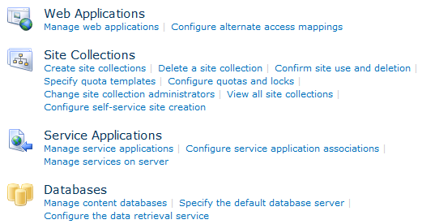

* 1. Return to the **Application Management** page and click the **View all site collections** hyperlink. Here all site collections for the selected web application are listed.
  2. Return to the **Application Management** page and click the **Manage content databases** hyperlink. On this page all content databases are listed per web application.
  3. Return to the **Application Management** page. Clicking the Specify the default database server would allow you to change the database server. The Service Applications will be explained in the 3rd exercise.
  4. Return to the **Central Administration** home page.

1. Click the **System Settings** hyperlink.

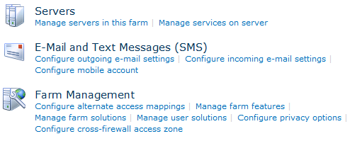

1. The **Systems Settings** page allows you to manage the different system settings. Using the **Manage servers in this farm** hyperlink would allow you to manage the servers in the farm.

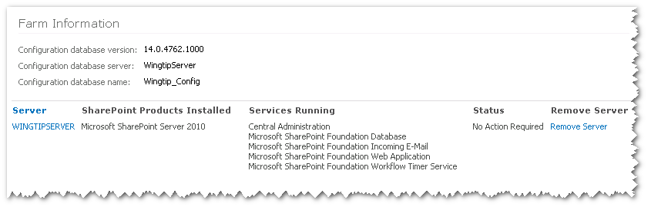

* 1. Also on the **Systems Settings** page, under the **Farm Management** section you find several links to manage farm features, farm solutions user solutions, etc.

1. Click the **Security** hyperlink in the quick launch. This avoids going back to the **Central Administration** home page.

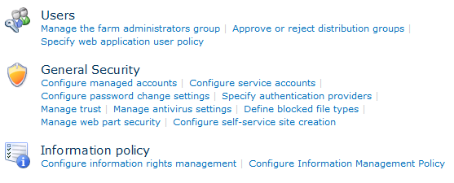

1. In this page you can manage everything that has to do with security:

Manage farm administrators

Configure managed accounts

Specify authentication providers

Manage antivirus settings

Configure information policies

1. Click the **General** **Application Settings** hyperlink in the quick launch.
2. From here you can configure settings for InfoPath, Site Directory, SharePoint Designer, Search, Reporting Services and Content Deployment.

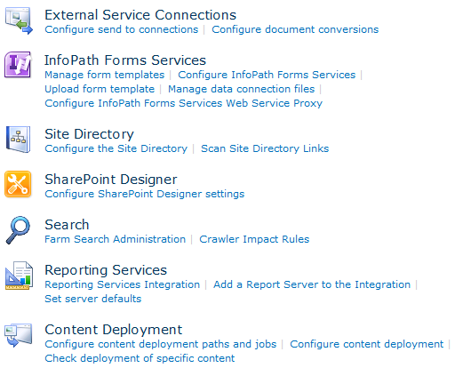

* 1. Return to the **Central Administration** home page.

In this exercise you became accustomed with SharePoint 2010 Central Administration.

### Exercise 2: Working with Managed Timer Jobs

This exercise you will walk you through the timer job definitions and the managed timer jobs.

1. From within the **Central Administration** home page, select the **Monitoring** hyperlink.
2. This brings you to the page from where you can manage settings on Health Analyzer, Timer Jobs and Reporting. Notice the section on **Timer Jobs**.

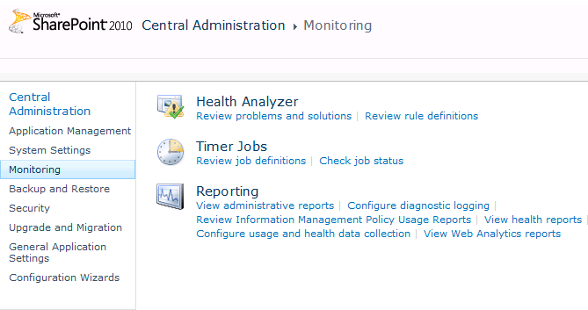

1. Within the Timer Jobs section, click the **Review job definitions** hyperlink. This brings you to a page where all timer job definitions are listed with the web application they run on and the schedule.

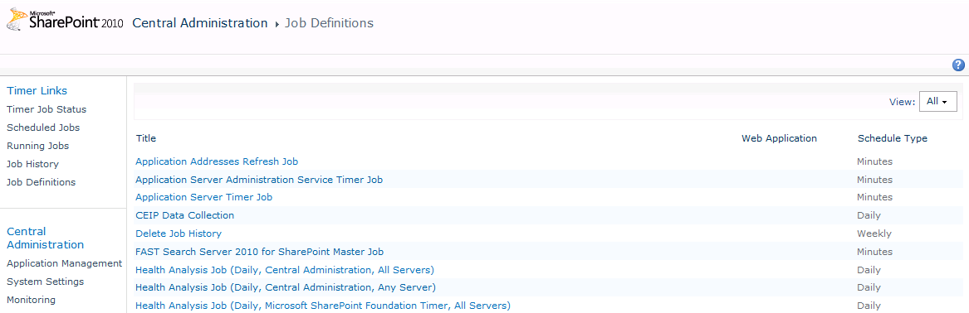

1. In the right upper corner you see a dropdown list from where you can change the view to **Service** or to **Web Application**. This will filter the list of job definitions. Note that if you select either of these filters you will not see any job definitions because you have not yet created any service applications or Web applications within the farm.
2. Notice the links on the left-hand side of the page in the **Timer Links** sections.

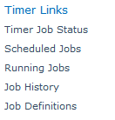

1. Click on the **Job History** link to navigate to the page that shows which timer jobs have run recently and when. It also indicates whether the timer job ran successfully.

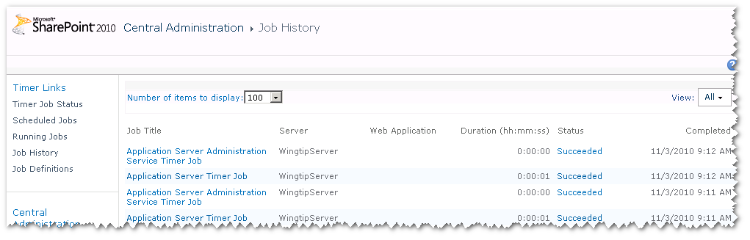

1. Click on the **Job Definitions** link to navigate back to the page that shows timer job definitions. Scroll down through the list and click the job definition named **Delete Job History**. This takes you to a page where you can inspect, schedule and run this job definition. You should be able to verify that this job definition is currently configured to run once a week very early on Sunday morning.

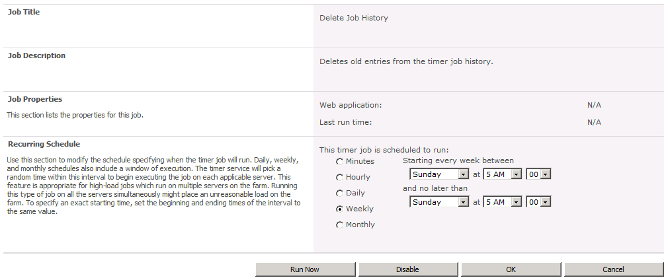

1. Click the **Run Now** button to immediately run the job..
2. Notice the links in the quick launch. These links allow you to quickly navigate between job status, scheduled jobs, running jobs and job history.

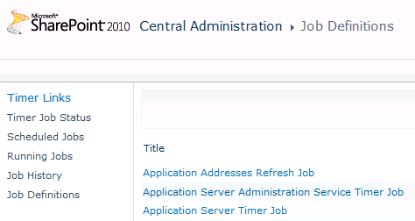

1. Click the **Scheduled Jobs** hyperlink. This brings you to page where all scheduled timer jobs are listed, ordered following their next start time. This is a big enhancement compared to what was available out of the box in SharePoint 2007. Clicking the name of the timer job will again bring you to the timer job details page.
2. Click the **Running Jobs** hyperlink. You will see which jobs are currently running and their progress.
3. Click the **Job History** hyperlink. Notice the status of the jobs listed. All jobs that have run are listed here with a status, the time they needed to complete and the time at which they completed.
4. The timer job status is displayed as a hyperlink. Clicking the hyperlink displays a table at the top of the page with more details about the status. This is interesting when a job fails.
5. Return to the **Monitoring** page and click the **Check job status** hyperlink under the Timer Job section.

This exercise you walked you through the timer job definitions and the managed timer jobs.

### Exercise 3: Registering Managed Accounts

SharePoint 2010 allows administrators to pre-configure managed accounts to be used when configuring Service applications and Web applications. This way administrators don't have to remember or lookup usernames and passwords for service accounts every time they configure a new service application or web application.

1. Go to Central Admin and click on the **Security** section.
2. Create a managed account for **WINGTIP\sp_serviceapp**
3. Select the **Configure managed accounts** hyperlink.
   1. Notice that the **sp_farm** account is already listed.
   2. Click the **Register Managed Account** button.
   3. Specify **WINGTIP\sp_serviceapp** as user name and **Password1** as password.
   4. Click the **OK** button.
   5. The **sp_serviceapp** account appears now in the list of managed accounts.
4. Create a managed account for **WINGTIP\sp_webapp**
5. Select the **Configure managed accounts** hyperlink.
   1. Click the **Register Managed Account** button.
   2. Specify **WINGTIP\sp_webapp** as user name and **Password1** as password.
   3. Click the **OK** button.
   4. The **sp_webapp** account appears now in the list of managed accounts.

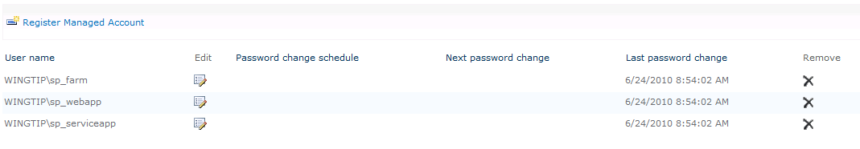

1. Return to the **Security** page.

In this exercise you created a few managed accounts.

### Exercise 4: Creating a Service Application Instance by Hand

In this exercise you will manually configure a number of service applications like the Word Automation Service, the Visio Graphics service and the Web Analytics service.

1. First you are going to take a look at the services that are already installed.
2. On the home page of **Central Administration**, locate and click the link with the caption **Manage services on this server** under the System Settings section.

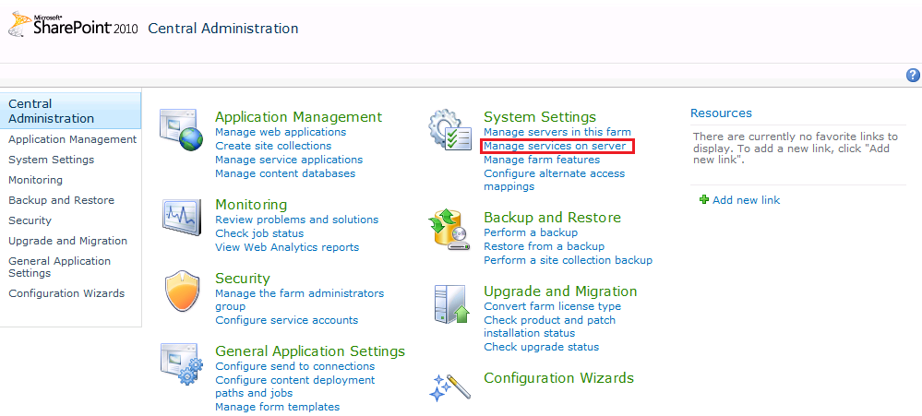

* 1. This brings you to the **Services on Server** page. Notice that a number of services are started, but a number of others not.

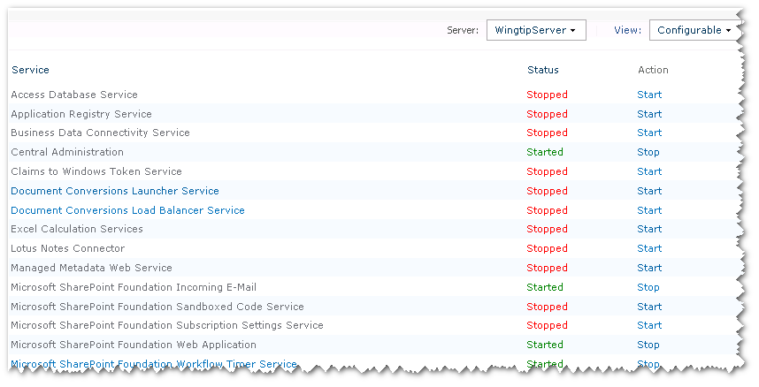

1. The first service application that you are going to create is the **Word Automation Service**. This service allows you to perform file operations on the server that previously required automating desktop Word, like conversions between document formats (e.g. DOC to DOCX) , converting to fixed formats (e.g. PDF or XPS) , updating fields, importing "alternate format chunks", etc.
2. Scroll down to the bottom of the page until you find the **Word Automation Service**. You see that the service is stopped.
3. Click the **Start** hyperlink to start the service.
4. Now we have to create the service application. Return to the **Central Administration** home page and choose **Manage service applications** under the Application Management section.

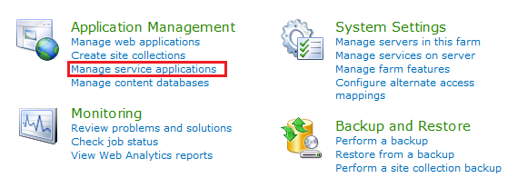

1. At this point you should only see two service applications that were automatically created and configured at farm creation time.

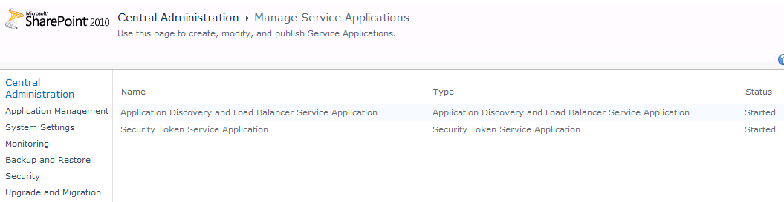

1. In the **Service Applications** page select the **New** button and choose **Word Automation Services**.

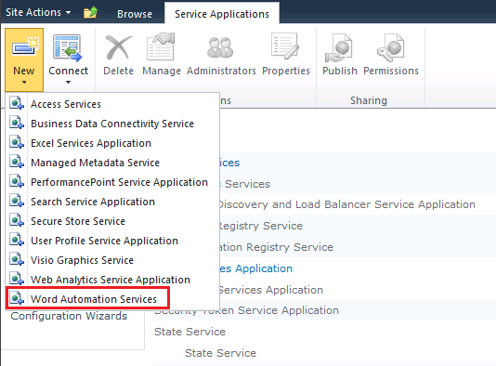

1. A dialog where you can create the new service application is displayed.
2. Give it the name **Word Automation Services**.
   1. Create a new application pool and give it the name **Wingtip Service Apps**.
   2. Choose the **WINGTIP\sp_serviceapp** managed account as worker process identity.

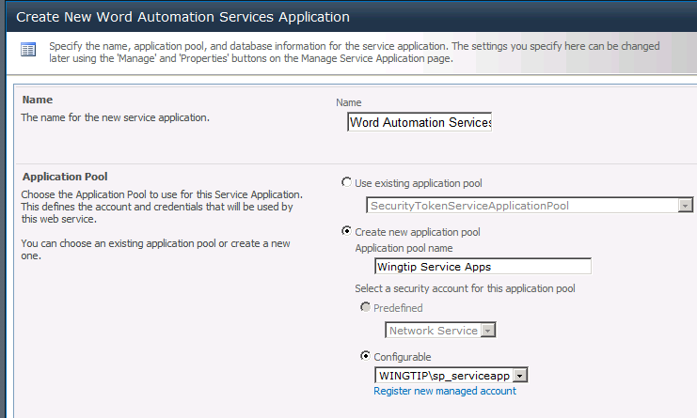

* 1. Make sure to check the checkbox with the option **Add this service application's proxy to the farm's default proxy list**.

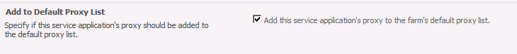

* 1. Click the **Next** button.
  2. In the second page of the dialog you have to specify the database server and the database name that will be used by the service application. The Database Server setting should be set to **WingtipServer**. Enter in a Database Name of **WordAutomation_ServiceAppDB** and click the **Finish** button.

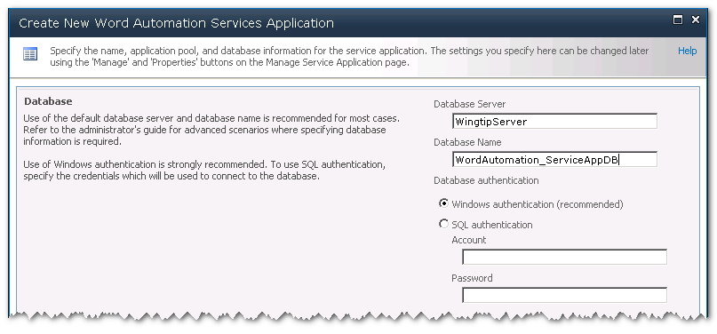

* 1. Click the **Finish** button.
  2. This brings you back on the **Service Applications** page. Scroll down and note that the **Word Automation Service** application is created and that the **Word Automation Service** is started.

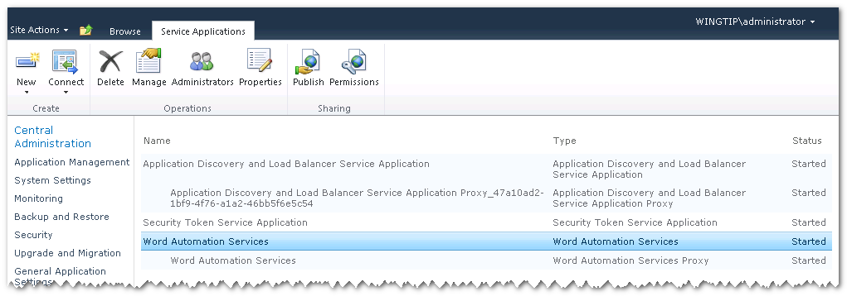

In this exercise you created a new service application manually.

### Exercise 5: Configuring Service Applications using the Farm Wizard

Now you have seen how to create a new instance of a service application by hand in Central Administration. In this final exercise you will automate creating several service application instances using the SharePoint 2010 Farm Wizard.

1. From the Home page of Central Administration, click the **Configuration Wizards** link.
2. You should now be on the Configuration Wizards page. You can see there is only one wizard named **Farm Configuration**.

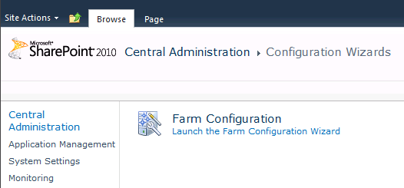

1. Click on the link which reads **Launch the Farm Configuration Wizard**.
2. You should see a page which allows you to start the wizard. Click the **Start the Wizard** button.

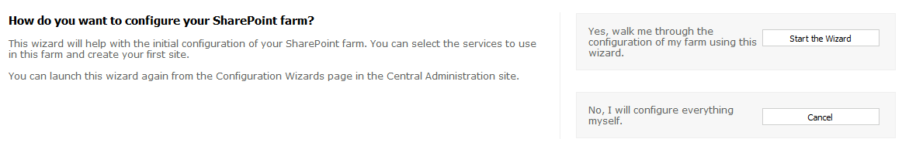

1. The wizard starts by taking you to the **Configure your SharePoint Farm** page. Configure the Service Account setting with managed account named **WINGTIP\sp_serviceapp**.

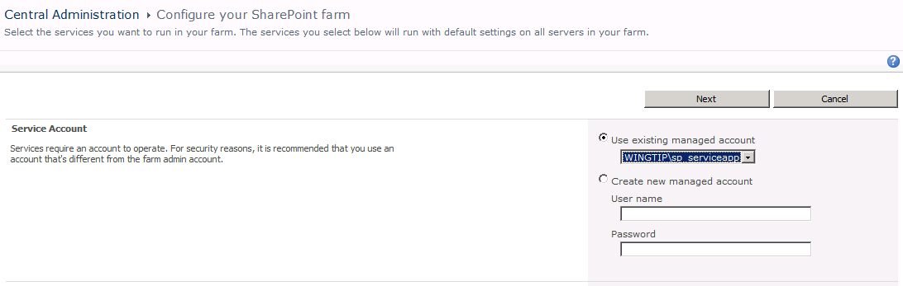

1. In the **Services** section, you must select what service applications you want configured. You should note that the Word Automation Services check box is checked and disabled because you created the service application instance for it earlier in this lab. Select the service applications shown in the following screenshot and make sure you uncheck those that you will not be using.

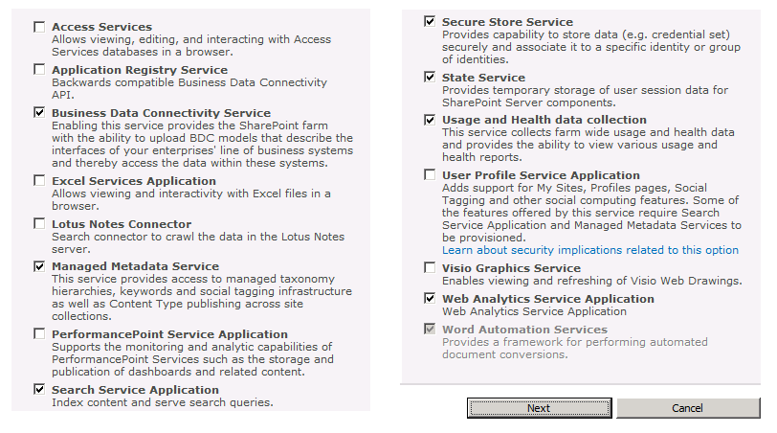

1. Click the **Next** button. At this point the wizard will begin to do its work. This might be a good time to take a 5-10 minute break because the wizard will run for a while.
2. When the Farm Wizard finishes creating and configuring the farm's service applications, it then creates a new Web application using a public URL based on the Web servers computer name which in this case is http://wingtipserver. After the farm wizard has created this Web application, it displays a page that allows you to create a new site collection at the root. Fill out this page using the information in the following screenshot.

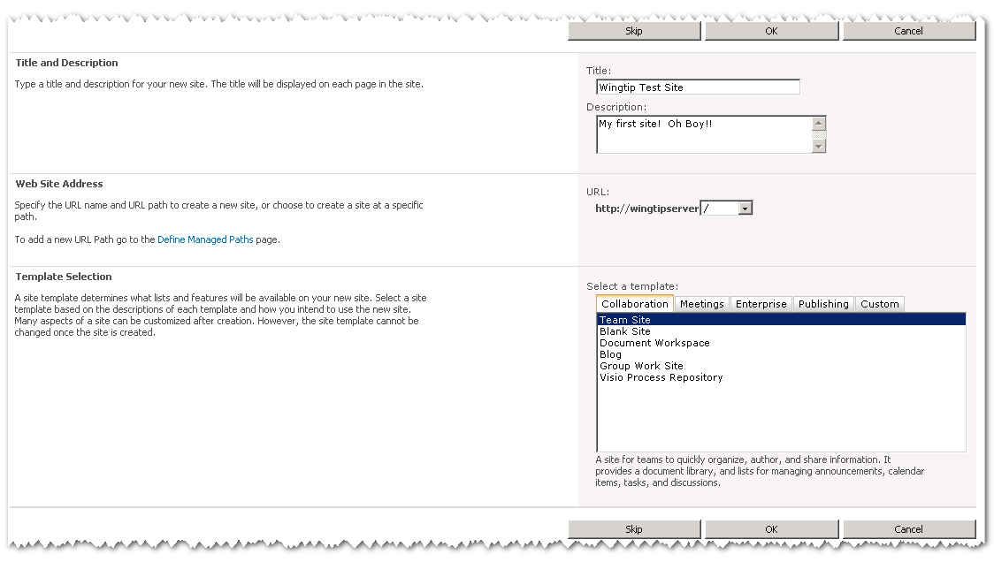

1. Click **OK** to have the Farm Wizard create the new site collection for you at http:// wingtipserver.
2. When the Farm Wizard completes, it displays the following page. Click the **Finish** button to return to the home page of Central Administration.

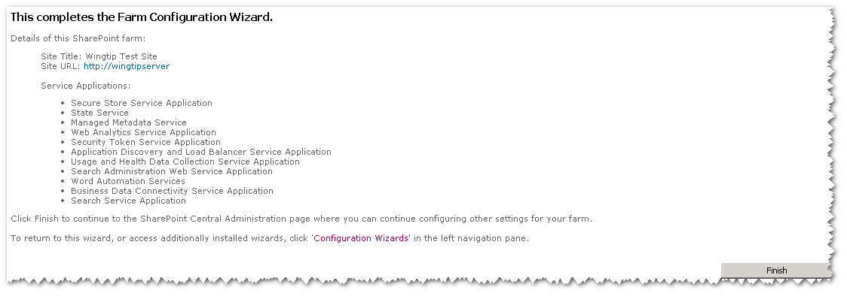

1. Now return to the **Manage Service Applications** page so that you can see the new service application instances that were created and configured by the Farm Wizard.

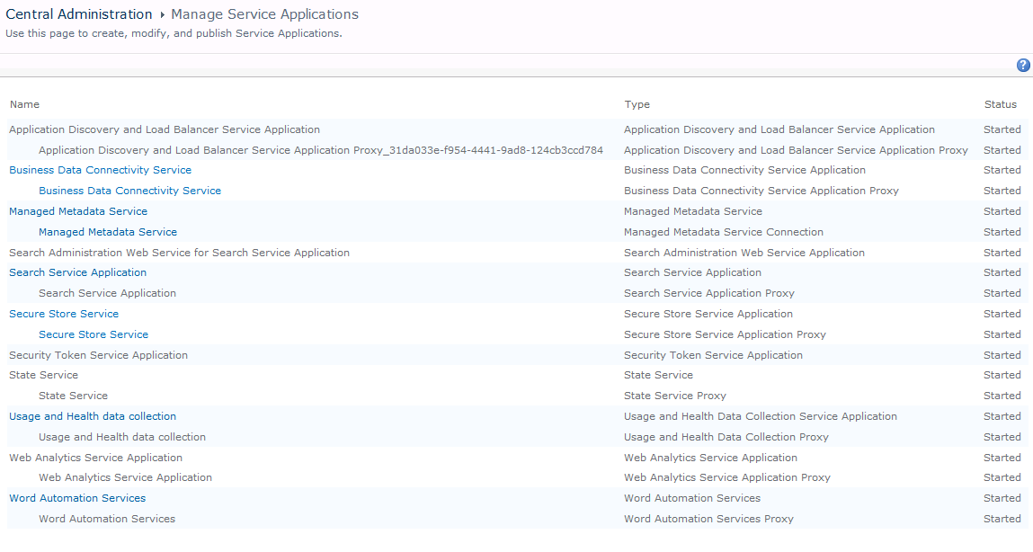

1. As a final step, reward yourself by navigating the new site that was created by the Farm Wizard at [http://wingtipserver](http://webserver).

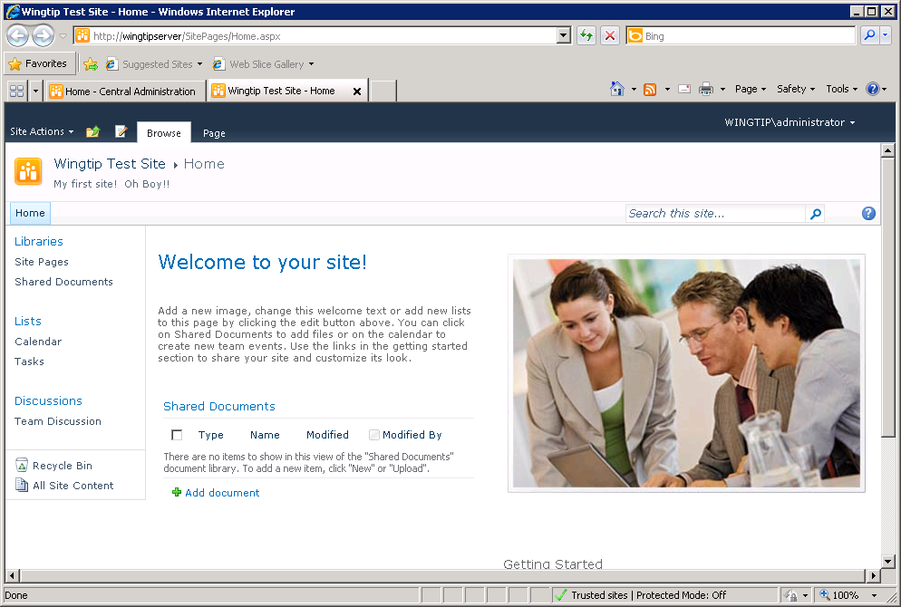

In this exercise you created the necessary service applications and the first SharePoint 2010 Team Site.